Instructions: Creating Sensor Readings
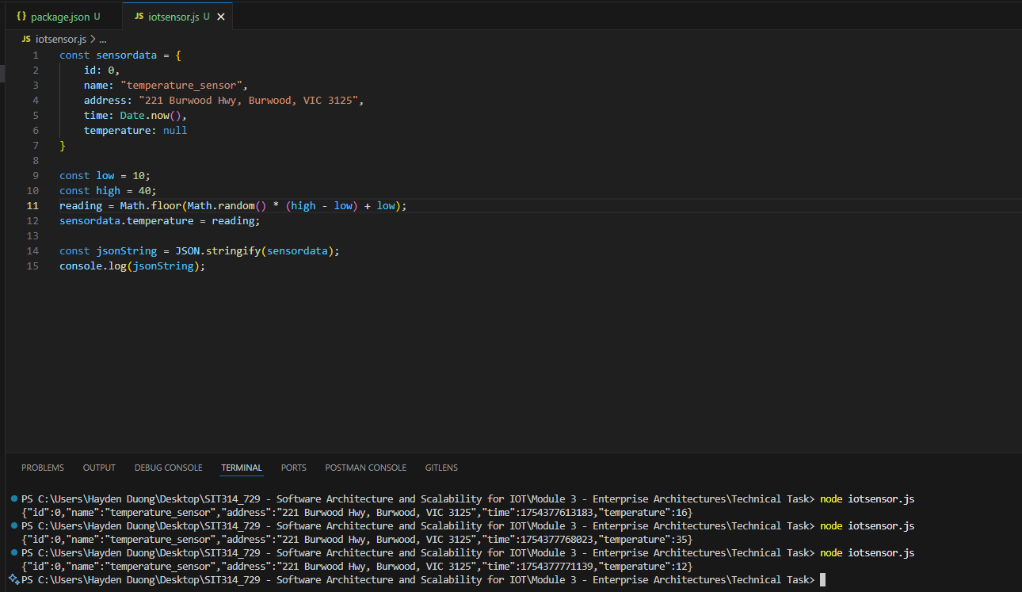
Picture 1 – Results gained from random temperature generator code.

Instructions: Storing Sensor Readings
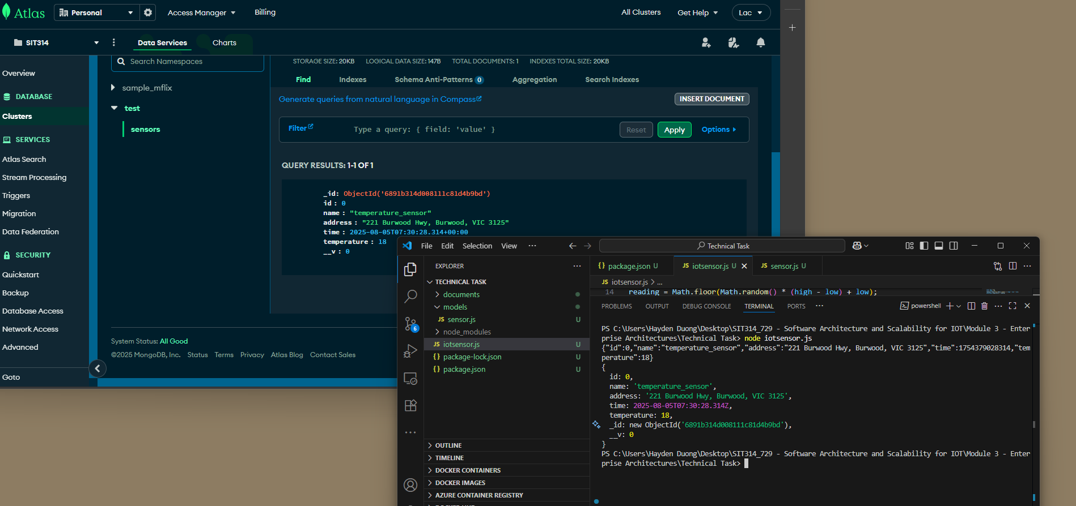
Picture 2 – Successfully create a new Sensor and stored on MongoDB Atlas
Scalability of IoT Data Storage
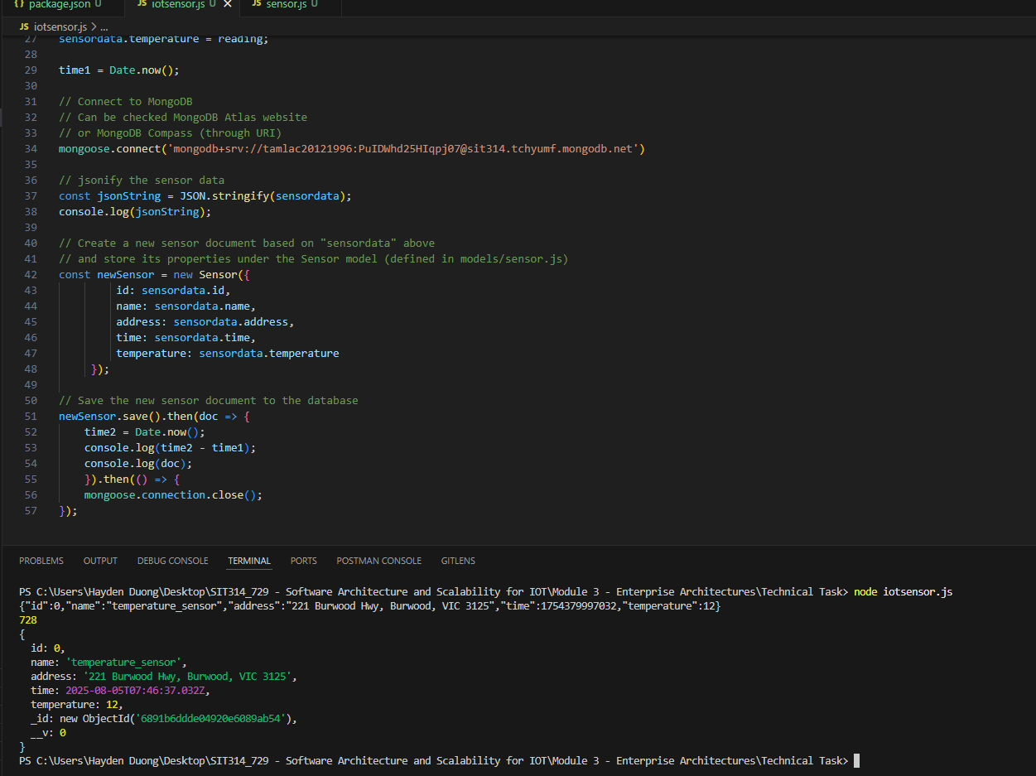
Picture 3 – It took 782 ms ~ 0.782 second to store the sensor data to database.
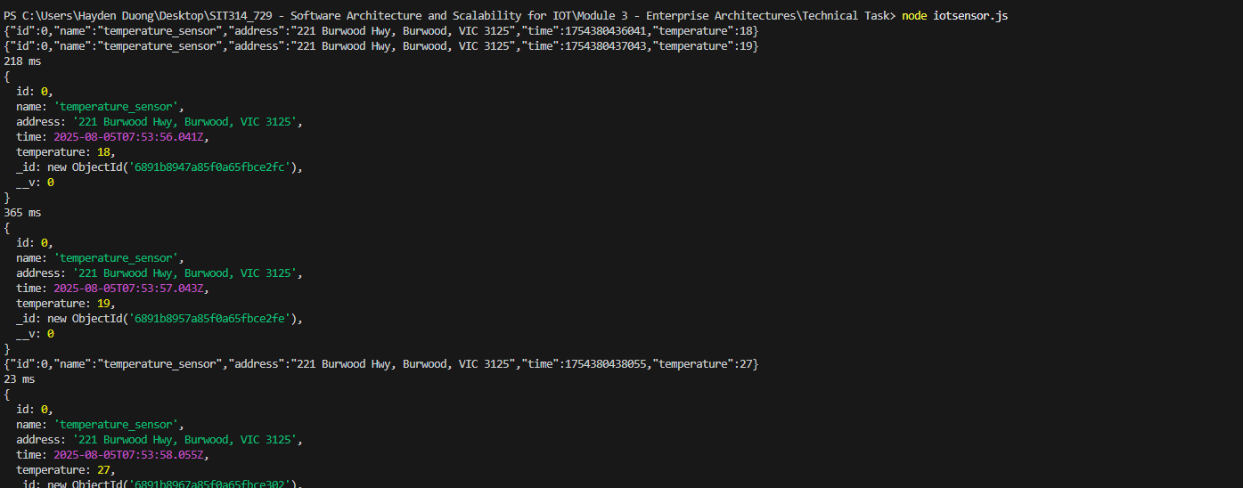
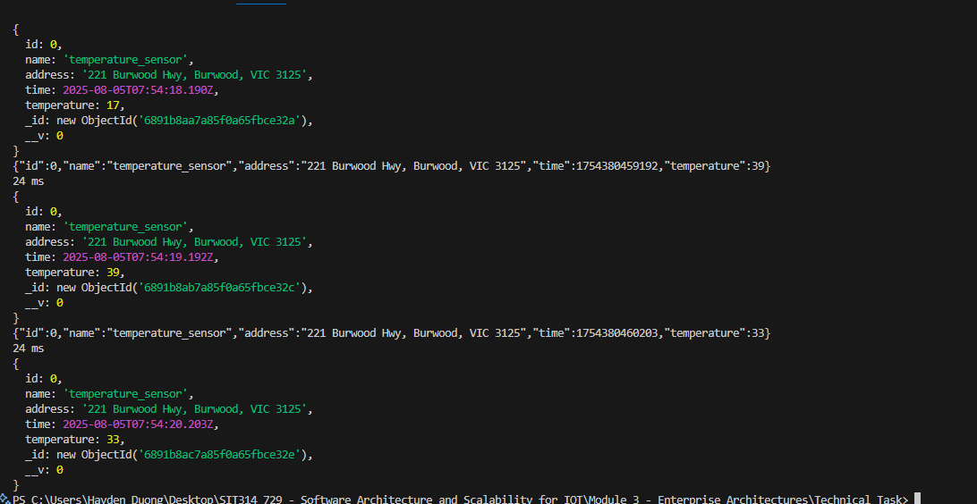
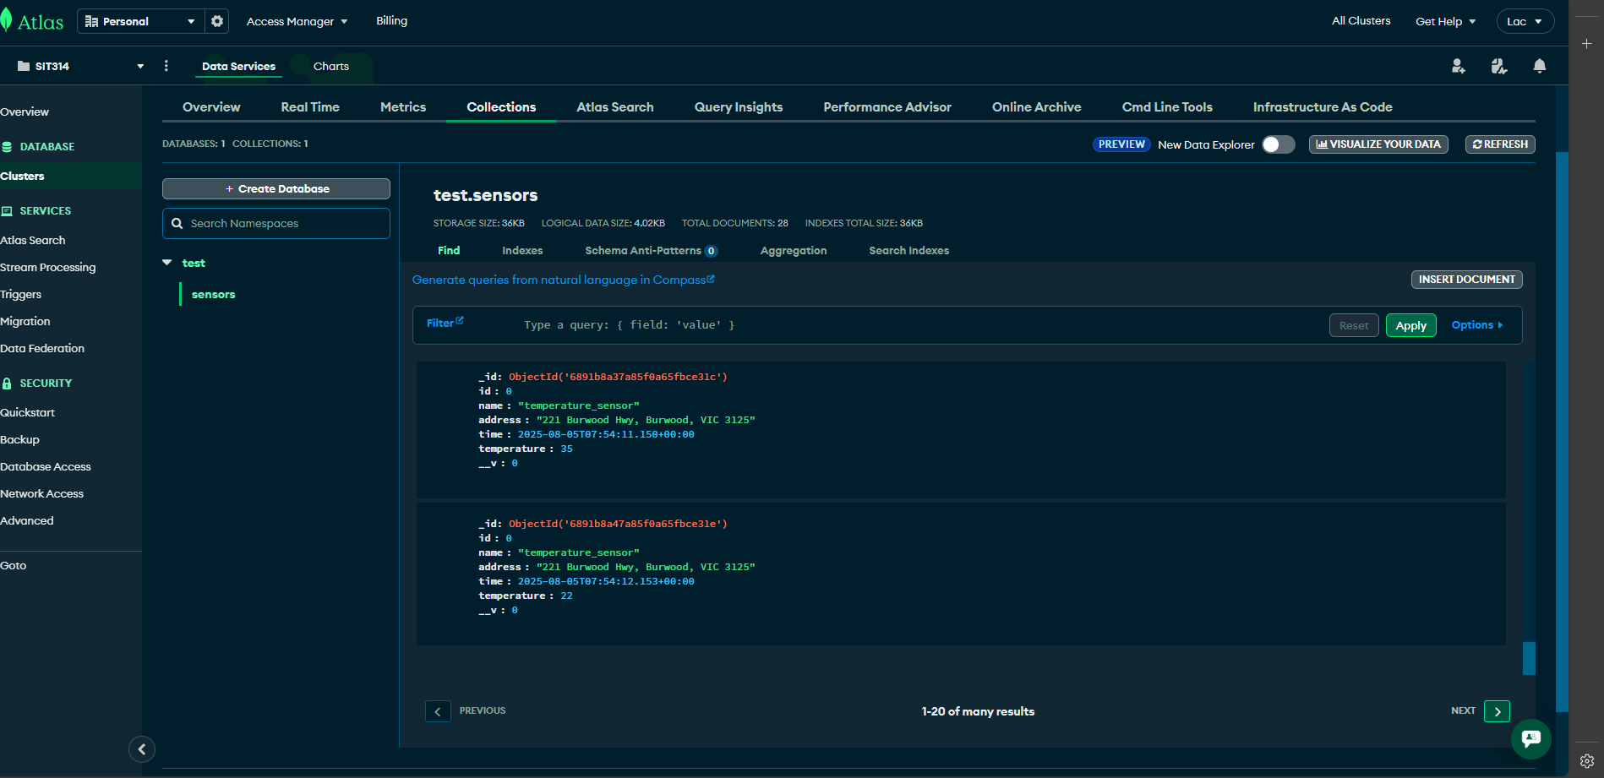
Picture 4, 5, 6 – Generated sensor data are stored successfully on MongoDB.

